# Background

*Vndr is being undertaken as a multi-channel selling platform to cross-list products to marketplaces that haven’t been used as a 3rd party service. The idea sparked from my friend who spent a countless number of hours uploading products manually to each service. The project is intended for vintage clothing sellers, like my friend who would like to grow their customer-base by having products on selling apps such as - Poshmark, Depop, and Mercari Marketplace. Normally, users will have to upload their products manually to each app, and by automating the process, it’ll allow users to focus more on the important parts of their growing business.*

# Benefits

*With its’ modern dashboard, users of the app can sell on multiple platforms by using multi-upload tasks, and possibly be led to an increase of sales and an outreach of customers who love their products. The whole goal is to maximize the user’s sales and grant them more leisure time. Auth tokens / login credentials will be stored on the device. For improved security they will not be stored in the cloud. Reply to all customers while being on-app.*

# Key Features

* *Multi-channel uploading to Poshmark, Depop, and Mercari Marketplace*
* *Automatic data conversion for sizes, categories, brands, etc.*
* *Inventory management, with synchronized editing & deleting of products across platforms*
* *Notifications and automatic removal of sold products*
* *Support chat-box of each platform to reply at user refunds or customer support*
* *Toggleable buttons to disable the platform from uploading products*

# Similar Applications

**SellBrite**

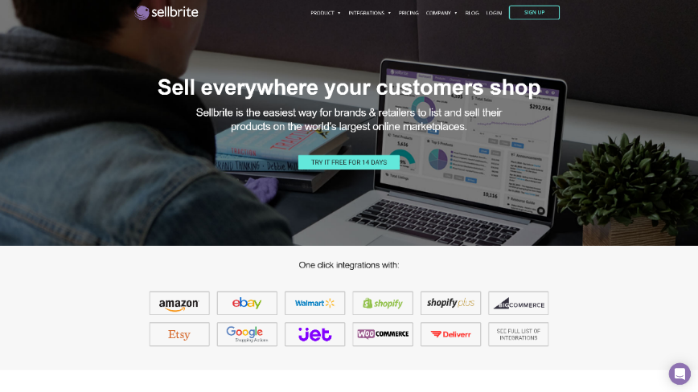

**ChannelAdvisor**

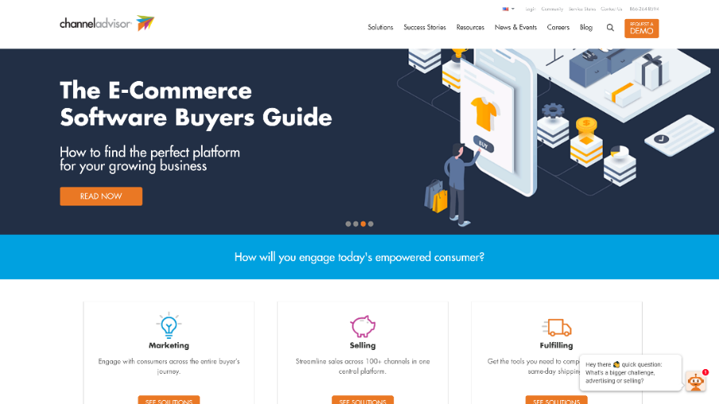

# Color Palette

# 

# Design Ideas

# Inventory Manager

# Image result for multi channel listing

# Adding a new channel (selling platform)

# 

# Approval Signatures

|  |  |  |
| --- | --- | --- |
| [Name], Student |  | [Name], Instructor |

**Channels Feature**

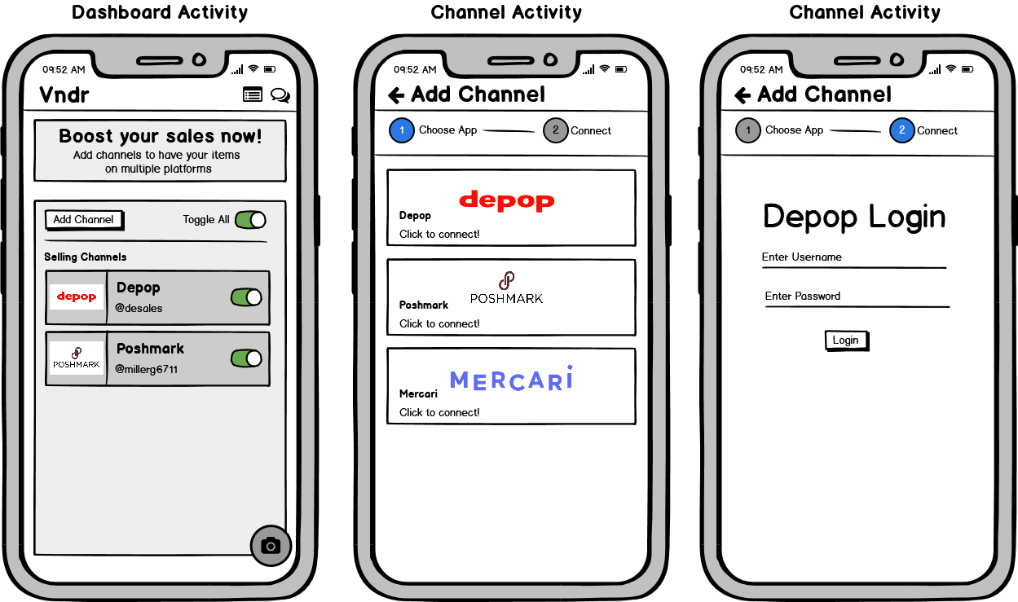

**Purpose and Background**

*Toggleable Channels/Platforms – The toggleable channels feature allow users to disable their products from being uploaded onto a certain platform if they already have it there. The functionality is needed to help users from having to delete products on the channels they don’t want and not have to remove pre-existing channels they’ve already added on Vndr. This feature is important because it’ll enhance the user’s experience and will give them an optimizable workflow so they can opt-out of channels they don’t necessarily need.*

**Workflow**

*Toggleable Channels/Platforms – The user will first login to their desired channel by clicking ‘add channel’ button. Once they’ve logged in, they’ll get redirected back to the dashboard and will be able to click the toggle all button under the header – to toggle the platforms on/off from uploading products. The user will also be able to pick a particular platform they want disabled by toggling it on/off in the selling channels list section.*

**Errors/Edge Cases**

* Invalid login credentials, or server error from Depop, Mercari, or Poshmark.
* Adding an account that’s already added.
* Failing to fill out the captcha for Poshmark
* For device configuration changes preserving data for username and password on login and the toggleable buttons and channels on the dashboard.

**Error Handling**

*The user will be prompted with a snack bar/toast message saying their login credentials are invalid using the message that came back from the server. If an account has already been added to the database, it’ll show a snackbar/toast message telling them they’ve already added their account. If they fail to fill out the captcha, it’ll display a message telling them the captcha needs to be filled out. Data will be saved in lifecycle methods in android.*

**Products Feature**

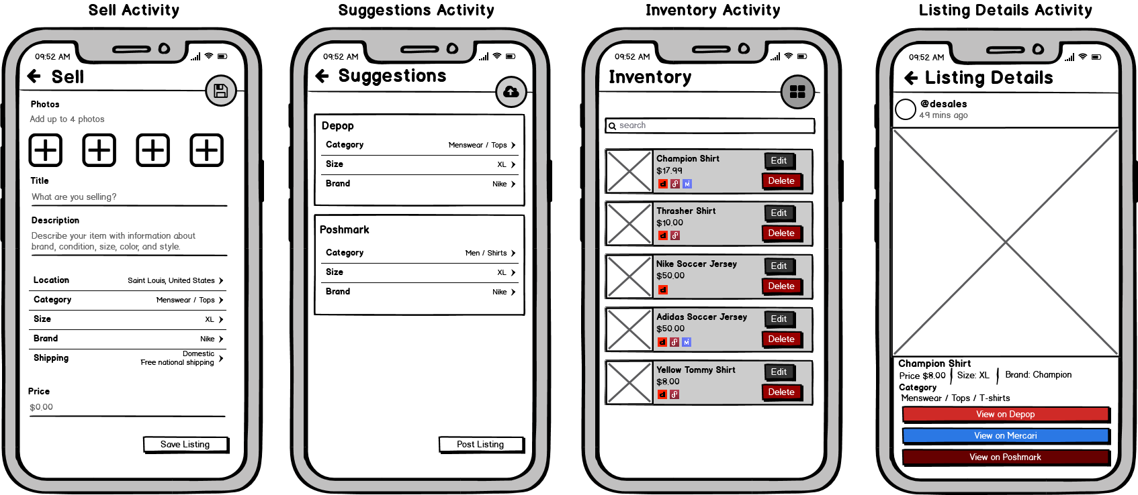

**Purpose and Background**

*Multi Upload – The multi-upload feature is a semi-automatic tool that enables the user to access multiple selling platforms through one service. The multi upload feature will upload a product to the Vndr application which in return will upload the item across the supported selling platforms they’ve chosen and have toggled. Users need this functionality for time saving and maximizing their work efficiency. Switching through multiple apps and uploading the same product is tedious and not efficient. The multi upload feature is the highlight of the project because no other service is offering this functionality with the particular channels I’ve chosen. The purpose of this feature is to maximize the user’s workload and save time with day-to-day uploading products.*

**Workflow**

*Multi-upload –Once the users have chosen their desired channels shown in feature one, they can start uploading their products to the platforms they like. The user will be able to click the camera icon in the bottom right corner which will take them to their camera app to upload a photo to the sell page. The photo will be automatically put in as the cover-shot and can be changed by dragging it around to another position. The user will upload the rest of their desired photos by clicking the plus icon, and will be able to add a title, description, location, category, size, brand, shipping info, and price for their item and lastly be able to click the ‘post listing’ button or the save fab in the top right. After the product has been uploaded, it’ll automatically save the item in the database and navigate them to the suggestions page and populate the suggested data for each platform so they can edit the data if it’s not correct or if some fields are missing.* *Once they’ve confirmed the data is correct, the user can post the listing and will be navigated to the inventory page, in which they can view all products and delete a particular product across all platforms using the ‘delete’ button. The user will also be able to search their products using the search bar at the top of the page and view the product by clicking on the ‘view’ button. Once navigated to the view product, they can view all items’ details and are able to view the product on the website by clicking ‘View Item on {Platform}’ button, which opens a new browser in the window.*

**Errors/Edge Cases**

* *Some apps may support different character, hashtag, and pricing limits*
* *A platform may not have a certain category, brand, or size.*
* *Invalid data / missing fields entered by the user.*
* *User could try to upload a product of**which they have no channels added.*

**Error Handling**

*The user will be prompted with a snack bar/toast message saying their product failed to upload with a given error message of the field that was invalid. The app will disable the post listing feature if no channels are added. If one platform doesn’t have the users specified option such as a certain category, it’ll prevent them from uploading to that platform and tell the user the platform doesn’t have the option and allow them to pick something else that is valid on the particular app.*

